**Molleth Ndlovu- 1718251**

**Assignment 1**

1.

CREATE DATABASE Faculty;

USE Faculty;

CREATE TABLE Departments(

Student_ID INT NOT NULL,

Department_Name VARCHAR(55) NOT NULL,

Lecturer_LastName VARCHAR(55),

Location_ID INT

);

EXEC sp_rename 'Departments.Student_ID', 'Name', 'COLUMN';

INSERT INTO Departments (Name, Department_Name, Lecturer_LastName, Location_ID)

VALUES (134563, 'Computer Science', 'Dewa', 1300);

INSERT INTO Departments (Name, Department_Name, Lecturer_LastName, Location_ID)

VALUES (343234, 'Data Science', 'Pravesh', 2100);

INSERT INTO Departments (Name, Department_Name, Lecturer_LastName, Location_ID)

VALUES (345621, 'Applied Mathematics', 'Christopher', 2100);

INSERT INTO Departments (Name, Department_Name, Lecturer_LastName, Location_ID)

VALUES (467231, 'Artificial Intelligence', 'Buthelezi', 4311);

INSERT INTO Departments (Name, Department_Name, Lecturer_LastName, Location_ID)

VALUES (452113, 'Robotics', 'Mamabolo', 2100);

INSERT INTO Departments (Name, Department_Name, Lecturer_LastName, Location_ID)

VALUES (345673, 'Physiscs', 'Shingange', 4300);

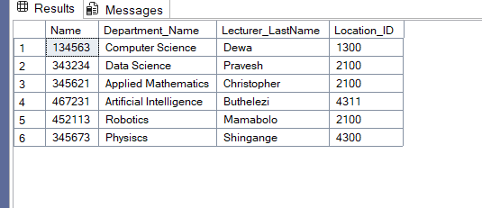

2.

SELECT Lecturer_LastName FROM Departments

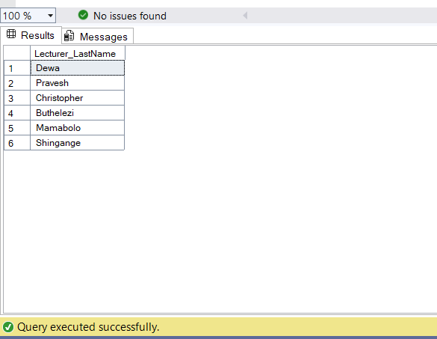

3.

CREATE DATABASE Employment;

USE Employment;

CREATE TABLE Employees (

Employment_ID VARCHAR(4),

Fname VARCHAR(50),

Lname VARCHAR(50),

Salary INT

);

INSERT INTO Employees (Employment_ID, Fname, Lname, Salary)

VALUES

('0011', 'Dumisani', 'Magwaza', 6500),

('0123', 'John', 'Smith', 14050),

('0212', 'Piet', 'Bothma', 23500),

('0023', 'Thapelo', 'Malatji', 9800),

('0321', 'Vaisdevan', 'Naicker', 12000);

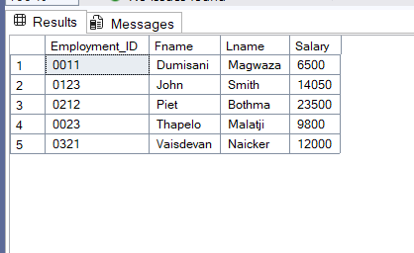

SELECT Lname, salary FROM Employees

WHERE salary > 12000;

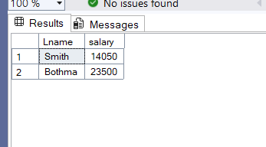

4.

SELECT Lname, Employment_ID FROM Employees

WHERE Employment_ID = '0212';

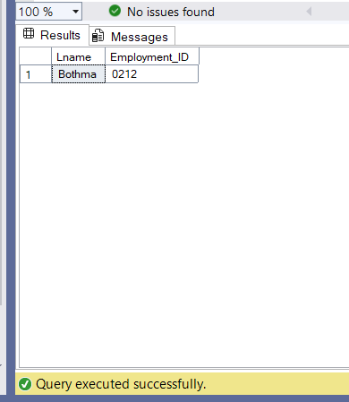

5.

SELECT Lname, salary FROM Employees

WHERE salary NOT BETWEEN 8000 AND 15000;

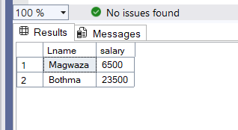

6.

CREATE TABLE Managers (

EmployeeID INT,

DepartmentName VARCHAR(50),

LastName VARCHAR(50),

DepartmentID VARCHAR(4),

Salary INT,

HireDate DATE

);

INSERT INTO Managers (EmployeeID, DepartmentName, LastName, DepartmentID, Salary, HireDate)

VALUES

(1, 'Accounting', 'Ndlovu', '0011', 12400, '2012-01-01'),

(2, 'Education', 'Pravesh', '0017', 32500, '2018-10-30'),

(3, 'Data Science', 'Dewa', '0022', 23450, '2009-04-06'),

(4, 'Healthy Sciences', 'Naicker', '0021', 16800, '2015-06-28'),

(5, 'Architecture', 'Naidoo', '0032', 19440, '2018-07-01'),

(6, 'Computer Science', 'Zuma', '0022', 21600, '2018-06-30'),

(7, 'Electronics', 'Vilakazi', '0024', 24800, '2014-09-01'),

(8, 'Physics', 'Motaung', '0024', 23500, '2020-08-01');

ALTER TABLE Managers

ADD HireDateText VARCHAR(20);

UPDATE Managers

SET HireDateText = FORMAT(HireDate, 'dd MM yyyy');

ALTER TABLE Managers

DROP COLUMN HireDate

EXEC sp_rename 'Managers.HireDateText', 'HireDate', 'COLUMN';

SELECT * FROM Managers

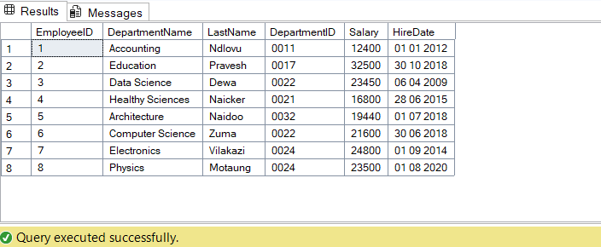

SELECT LastName, DepartmentID FROM Managers

WHERE DepartmentID IN ('0022', '0024')

ORDER BY LastName;

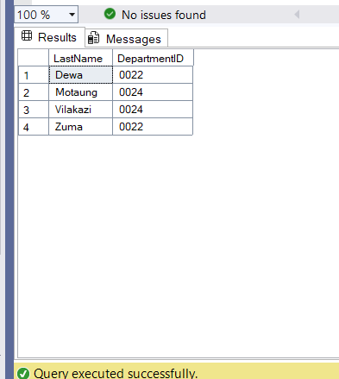

7.

SELECT LastName AS Employee, Salary AS [Monthly Salary] FROM Managers

WHERE Salary BETWEEN 15000 AND 22000

AND RIGHT(DepartmentID, 2) IN ('21', '24');

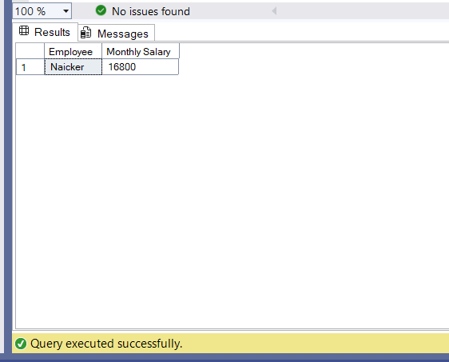

8.

SELECT LastName, HireDate FROM Managers

WHERE HireDate LIKE '%2018';

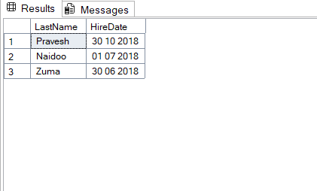

9.

SELECT LastName, Salary, HireDate FROM Managers

WHERE Salary > 20500

ORDER BY Salary DESC, LastName DESC;

